EXPERIMENT-1
AIM : Installation of Python IDE software and installation of Python “scikit learn” for ML.
Course Outcome: Use basic concepts of AI & ML.
Theory :
Python is a high-level, interpreted programming language widely used for software development, machine learning, and data science. To write and execute Python programs efficiently, it is recommended to use an IDE (Integrated Development Environment).
An IDE provides a single platform that includes a code editor, interpreter, debugger, and terminal, making it easier to develop and test programs. Popular Python IDEs include IDLE (which comes pre-installed with Python), PyCharm, VS Code, and Jupyter Notebook.
To begin, Python itself must first be installed.
(1) Visit the official Python website at https://www.python.org/downloads/ and download the latest version, such as Python 3.12.
(2) Run the installer and ensure that the checkbox “Add Python to PATH” is selected. This step allows Python to be accessed directly from the command line.
(3) After installation, the success can be verified by opening the Command Prompt and typing python --version, which should display the installed Python version.
(4) Once Python is installed, an IDE can be set up. For example, PyCharm can be downloaded from https://www.jetbrains.com/pycharm/download/.
Choose the Community Edition (which is free), run the installer, and follow the on-screen instructions to complete the installation.
(5) After launching the IDE, a new Python project can be created and linked to the installed Python interpreter. With this setup, Python programs can be written, executed, and debugged in a professional development environment.

Machine Learning requires specialized libraries to implement algorithms for tasks such as classification, regression, clustering, and model evaluation. scikit-learn is one of the most widely used Python libraries for this purpose.
Built on top of NumPy, SciPy, and matplotlib, scikit-learn provides prebuilt implementations of machine learning algorithms, data preprocessing tools, and model evaluation functions. Installing this library allows developers to create predictive models without needing to write complex algorithms from scratch.
Before installing scikit-learn, ensure that Python and the pip package manager are properly installed. This is as follows:
(1) To install the library, open the Command Prompt or terminal and type the command: pip install scikit-learn
This command will automatically download and install scikit-learn along with its required dependencies such as NumPy, SciPy, joblib, and threadpoolctl.
(2) Once the installation is complete, it can be verified by opening the Python shell or an IDE and running:
import sklearn
print(sklearn.__version__)
(3) If the version number of scikit-learn is displayed without any errors, the installation has been successful.
(4) With Python, an IDE, and scikit-learn installed, the system is ready for developing machine learning applications.
This setup enables users to preprocess data, train models, and evaluate predictions efficiently, making it an essential foundation for data science and artificial intelligence projects.

Program and Output:
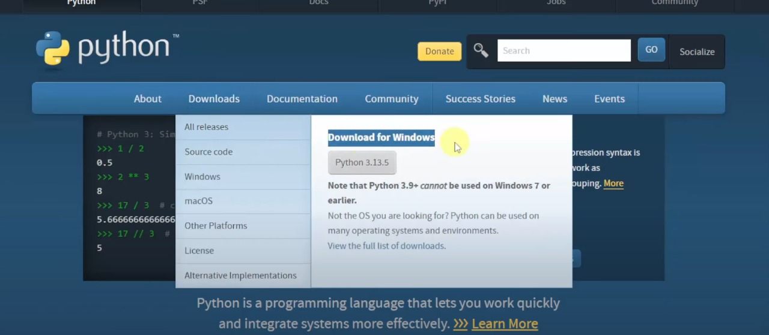

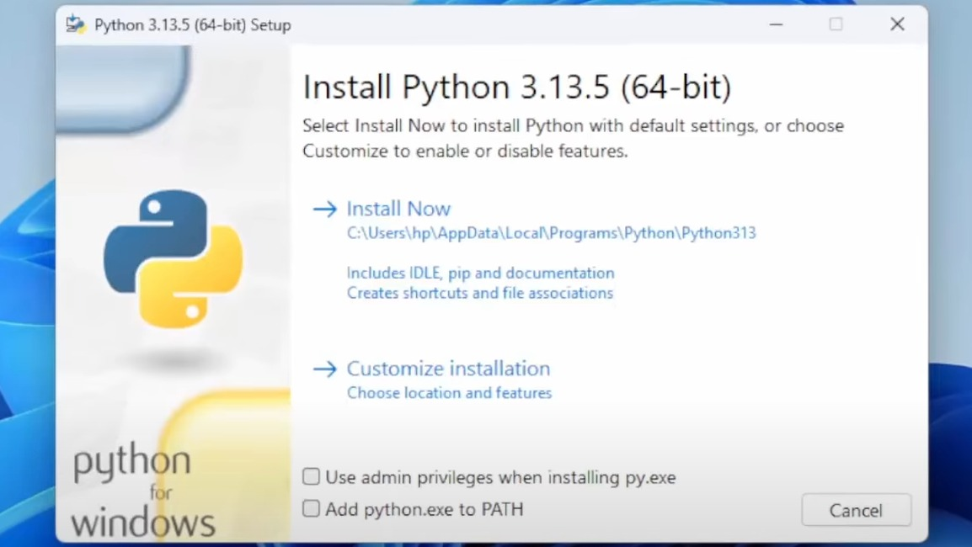
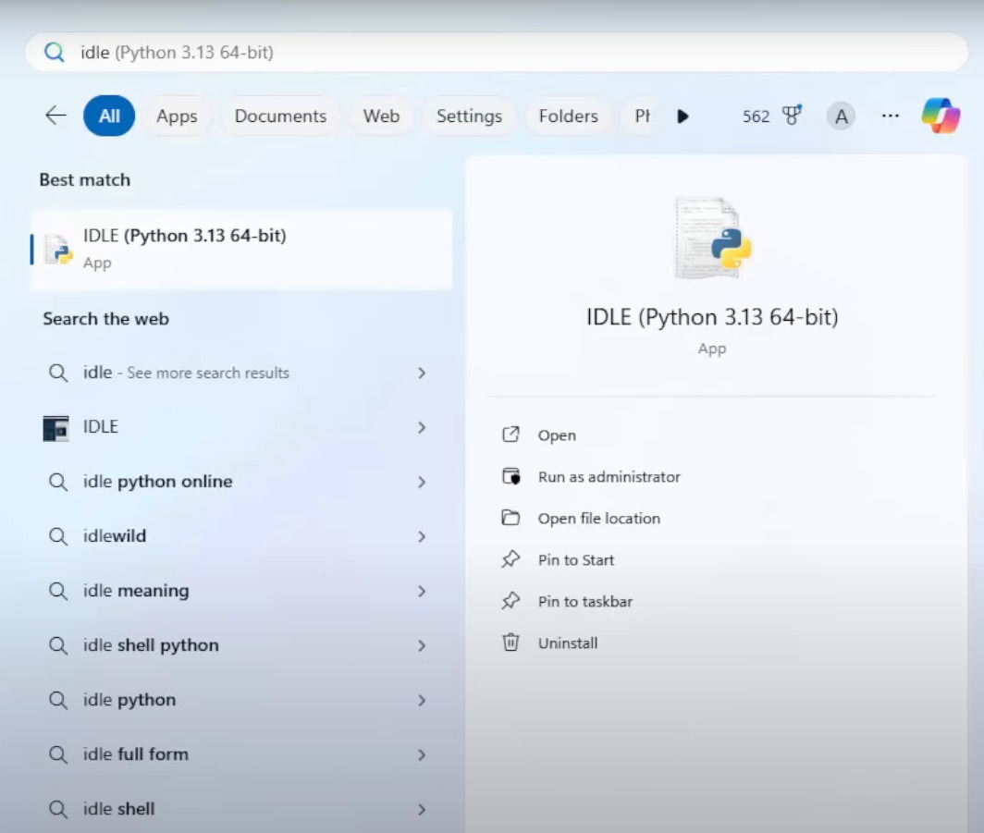

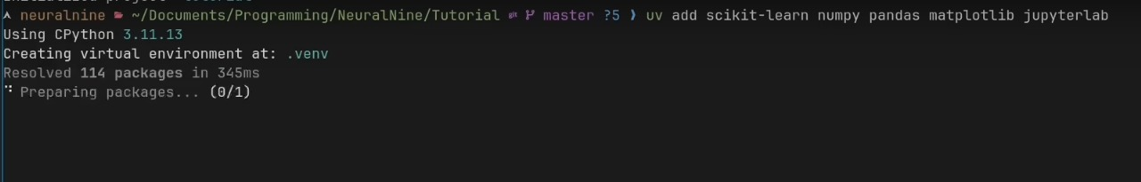

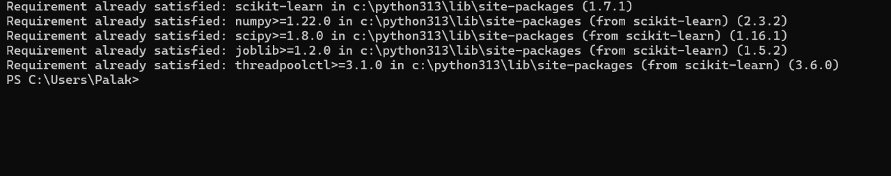
Conclusion: Hence this is how Python IDE software and Python’s “scikit learn” for ML is installed and utilize them.

EXPERIMENT-2
AIM: Utilizing Python libraries like NumPy, Pandas, Scikit-learn, and Matplotlib for data manipulation and visualization.
Course Outcome: Use basic concepts of AI & ML.
Theory:
Data manipulation and visualization are fundamental steps in data science and machine learning. Python provides a rich ecosystem of libraries that simplify these tasks, among which NumPy, Pandas, Scikit-learn, and Matplotlib are the most widely used. These libraries together enable efficient data handling, powerful computation, and clear presentation of insights.

1. NumPy (Numerical Python)
NumPy provides support for multi-dimensional arrays and a wide collection of mathematical functions to operate on them.
Its ndarray object allows fast and memory-efficient computations compared to native Python lists. It is the backbone for many other scientific libraries.
Key features include:
Creation of arrays, matrices, and numerical datasets.
Vectorized operations (element-wise computations without explicit loops).
Linear algebra, Fourier transforms, and random number generation.

2. Pandas
Pandas is designed for data manipulation and analysis, offering two main structures:
Series – one-dimensional labeled arrays.
DataFrame – two-dimensional tables with labeled rows and columns.
Pandas makes it easy to:
Import data from CSV, Excel, JSON, SQL, etc.
Clean and preprocess data (handling missing values, filtering, grouping).
Perform aggregations, joins, and reshaping of datasets.
Its intuitive syntax makes data preparation faster and more readable.

3. Scikit-learn
Scikit-learn is a powerful library for machine learning and predictive modeling.
It builds on NumPy and Pandas to provide:
Preprocessing tools (normalization, encoding, feature selection).
A wide range of algorithms for classification, regression, clustering, and dimensionality reduction.
Model evaluation and cross-validation methods.
Scikit-learn simplifies the complete ML workflow, from training models to testing and deploying them.

4. Matplotlib
Matplotlib is a comprehensive data visualization library.
It allows the creation of static, animated, and interactive plots such as:
Line graphs, bar charts, histograms, scatter plots, and pie charts.
Customizable elements (titles, labels, legends, colors, styles).
Integration with Pandas DataFrames for quick plotting.
Integration of Libraries
In a typical workflow:
NumPy handles numerical computations and array operations.
Pandas organizes raw data into clean DataFrames.
Scikit-learn applies machine learning algorithms to analyze or predict outcomes.
Matplotlib visualizes the results for better interpretation and decision-making.
By combining these libraries, Python becomes a complete environment for data analysis.
NumPy ensures efficient numerical processing, Pandas simplifies data manipulation, Scikit-learn provides machine learning capabilities, and Matplotlib creates meaningful visual representations.
Together, they form a powerful toolkit for extracting insights from data and communicating findings effectively.

Program and Output:
NumPy:

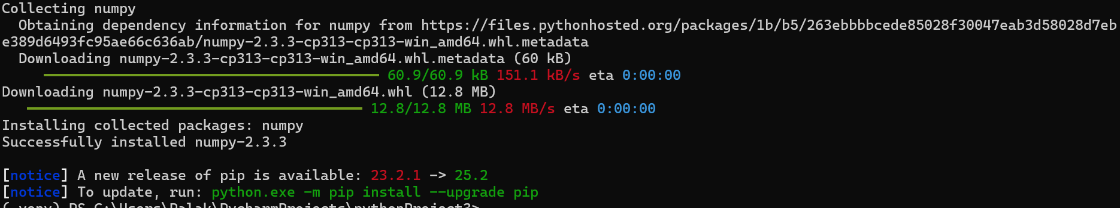

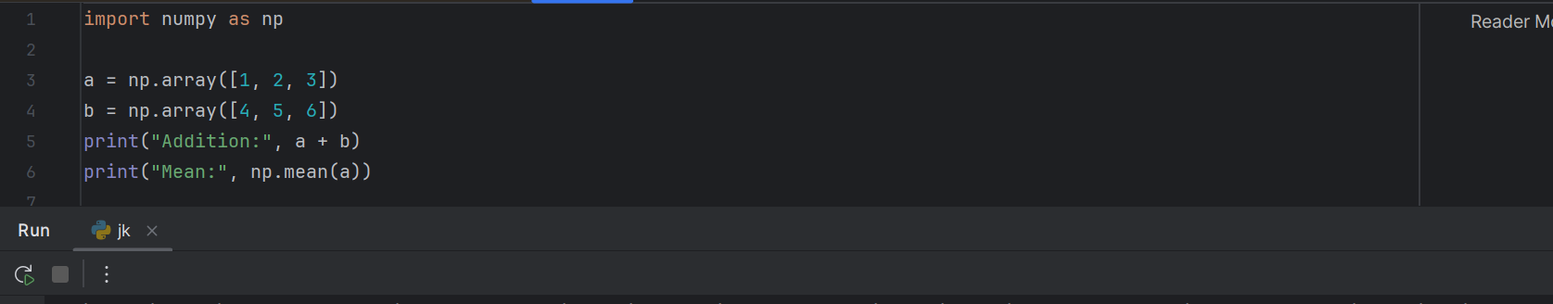
Pandas:
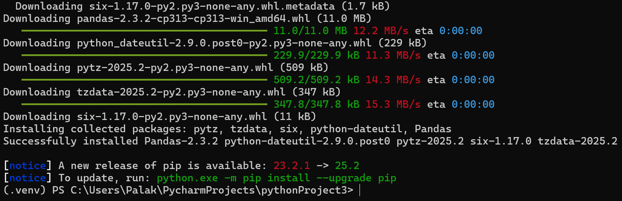

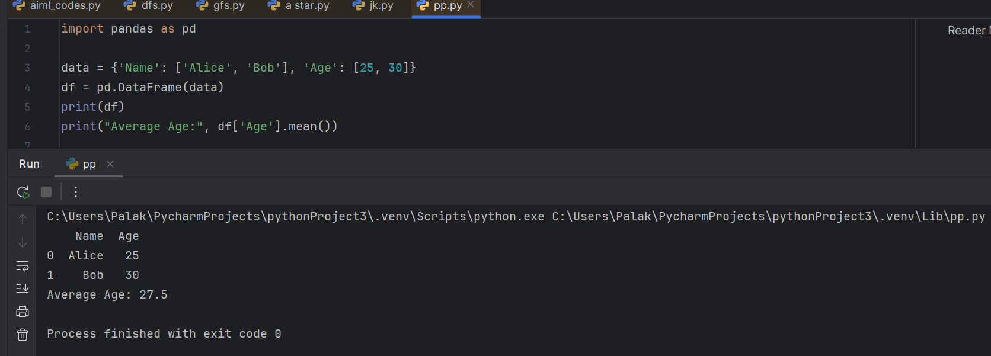
Scikit-learn:
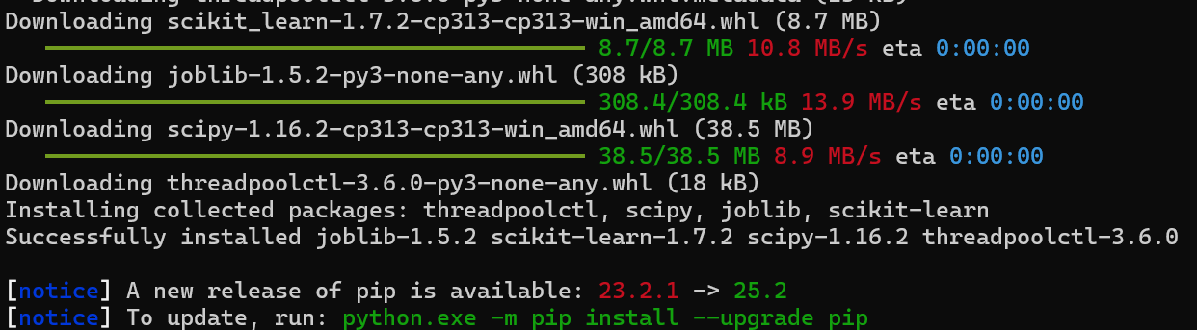

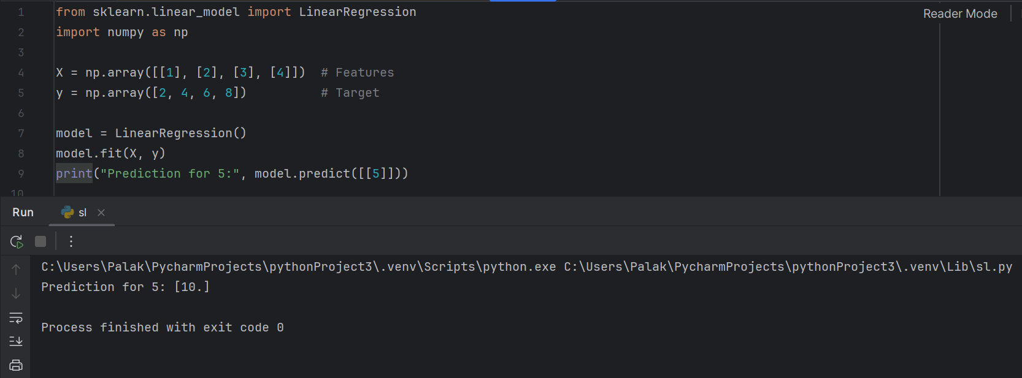
Matplotlib:
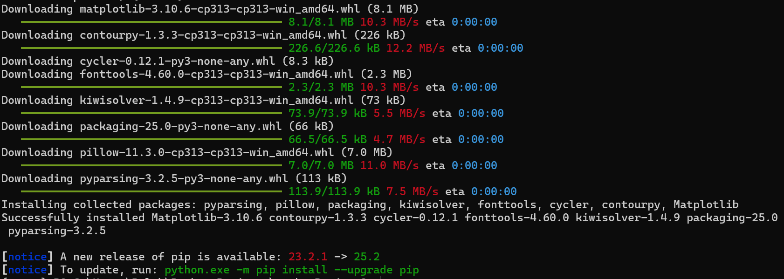
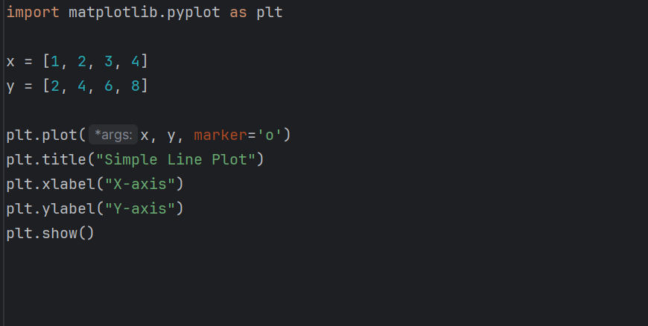
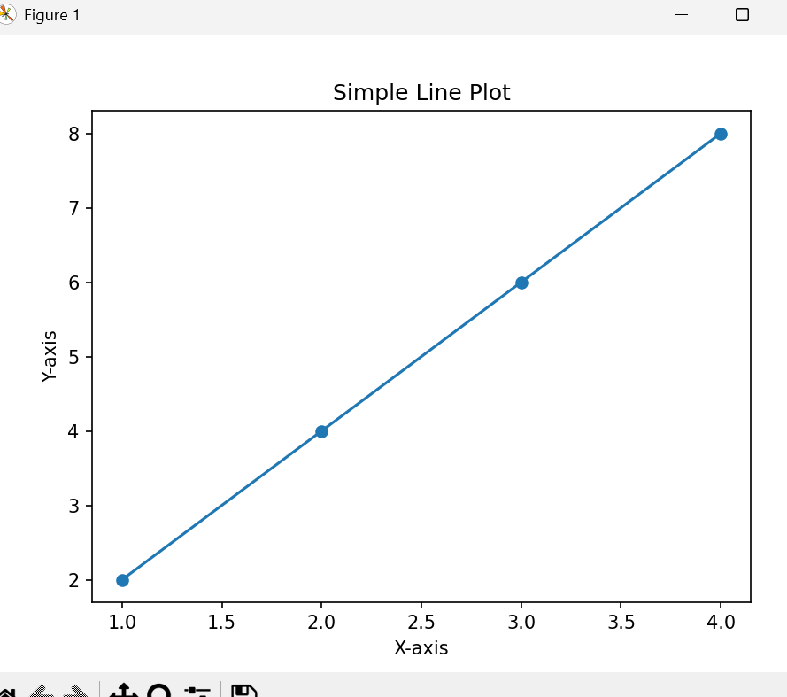

Conclusion: Hence this is how we utilize Python libraries like NumPy,
Pandas, Scikit-learn, and Matplotlib for data manipulation and visualization.

EXPERIMENT-3
AIM: Write program to Implement Breadth First Search Algorithm in Python
Course Outcome: Use basic concepts of AI & ML.
Theory:
Breadth First Search (BFS) is one of the most fundamental algorithms used for traversing or searching through graphs and tree structures. It is classified as an uninformed search technique, meaning it explores the graph systematically without using any prior knowledge or heuristic about the target node.
The main objective of BFS is to explore all vertices of a graph level by level, ensuring that the shallowest nodes are visited first before moving deeper. This property makes BFS an ideal choice for finding the shortest path in unweighted graphs, where all edges have the same cost.
The algorithm begins at a selected starting node, also known as the root node in a tree or the source vertex in a graph. It uses a queue data structure, which follows the First-In-First-Out (FIFO) principle, to keep track of nodes to be explored. Initially, the starting node is marked as visited and inserted into the queue.
BFS repeatedly removes the front node from the queue, processes it, and adds all of its unvisited neighboring nodes to the queue. This process continues until the queue becomes empty, indicating that all reachable nodes have been visited. The use of a queue ensures that nodes are explored in order of their distance from the source, resulting in a layer-by-layer traversal of the graph.
During traversal, BFS maintains a visited set to avoid revisiting the same node and to prevent infinite loops in cyclic graphs. It can handle both directed and undirected graphs and works effectively for both connected and disconnected components when implemented with multiple source nodes. Because BFS explores all nodes at a given depth before moving to the next, it guarantees that the first time a node is encountered, it is reached via the shortest path from the source in terms of the number of edges.
BFS is widely applied in various domains such as finding the shortest path in network routing, web crawling, peer-to-peer networks, social network analysis, and solving puzzles like the shortest moves in a game.
In Python, BFS is typically implemented using a queue from the collections.deque module and a dictionary or adjacency list to represent the graph. Overall, Breadth First Search is a robust and efficient algorithm for systematic exploration of graphs and serves as a foundation for many advanced graph-based algorithms in computer science and artificial intelligence.

Program:
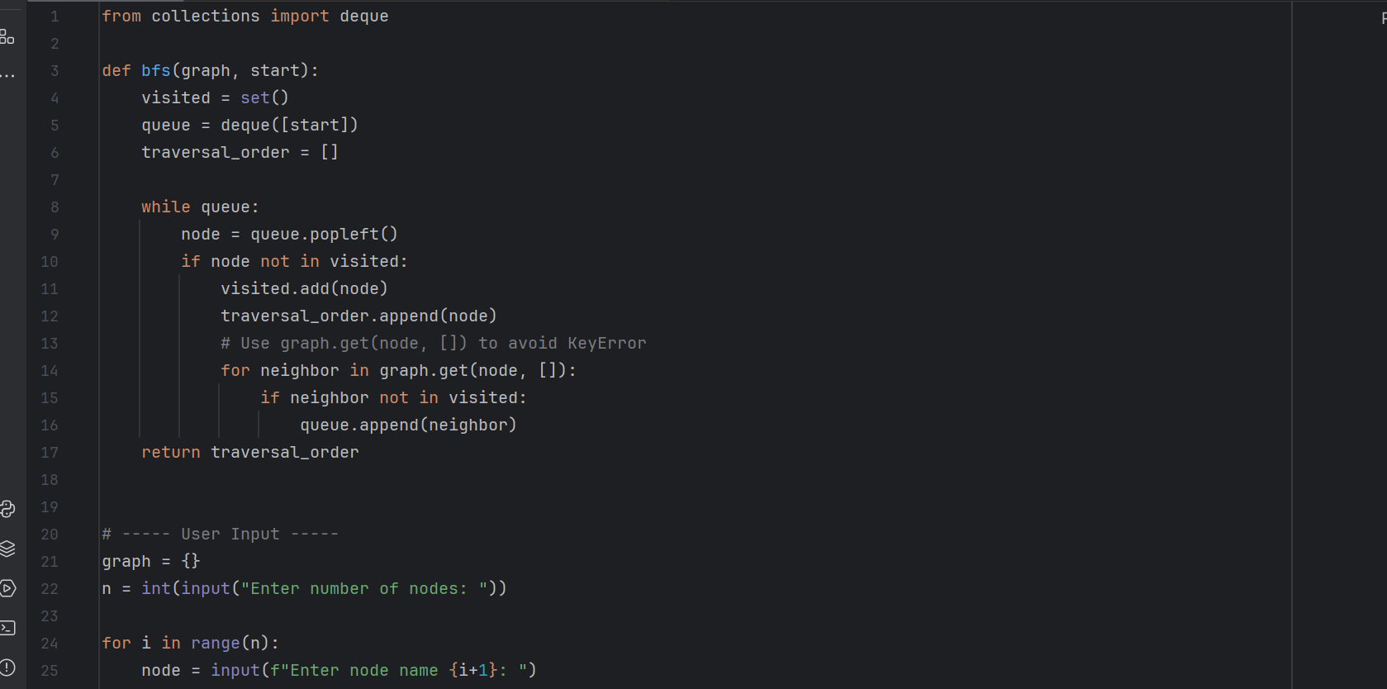

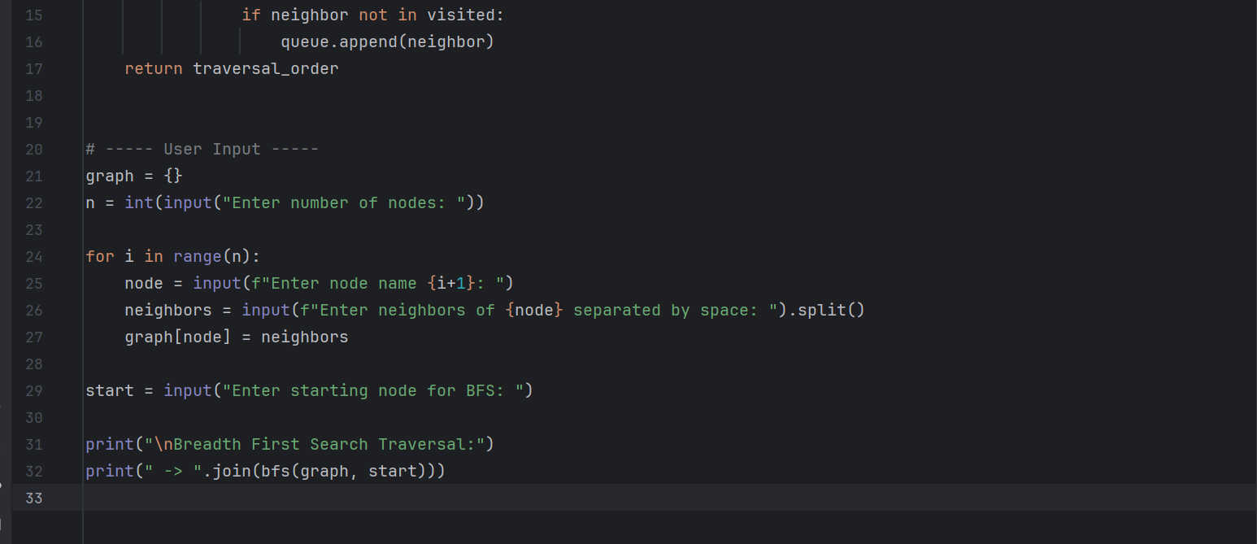

Output:

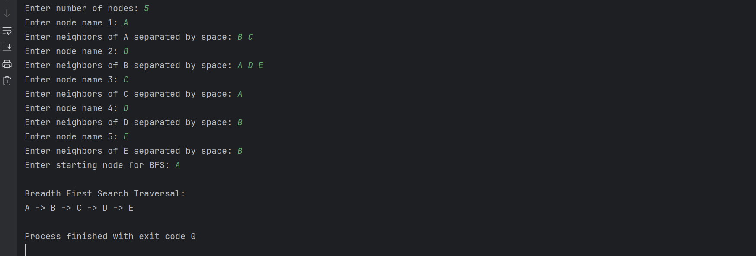

Conclusion: Hence this is the program to Implement Breadth First Search Algorithm (Uninformed) in Python.

EXPERIMENT-4
AIM: Write program to implement Depth First Search Algorithm (Uninformed) in Python
Course Outcome: Implement relevant search algorithms as applicable to Artificial Intelligence.
Theory: Depth First Search (DFS) is a fundamental algorithm used for graph and tree traversal. It is an uninformed search technique, meaning it explores the search space systematically without using any heuristics or prior knowledge of the goal node. The key idea of DFS is to explore as far as possible along each branch of the graph before backtracking, which gives it a depth-oriented nature. This makes DFS suitable for applications such as solving mazes, pathfinding in puzzles, topological sorting, and detecting cycles in graphs.
DFS starts from a given source or root node and marks it as visited to avoid repetition. From the starting node, it selects one of its unvisited neighbors and continues moving deeper into the graph.
If it reaches a node that has no unvisited neighbours, it backtracks to the most recent node with remaining unvisited neighbours and continues the process until all nodes are visited. This approach mimics a “go-deep-first” strategy. The traversal can be implemented either recursively, by leveraging the function call stack, or iteratively using an explicit stack data structure.
DFS operates on graphs represented as adjacency lists or adjacency matrices. It is particularly memory-efficient for large but sparse graphs because it only needs to keep track of the visited nodes and the current path. The time complexity of DFS is O(V + E), where V represents the number of vertices and E the number of edges, as each node and edge is explored once.
The space complexity depends on the depth of the recursion or the size of the stack; in the worst case, it can reach O(V). Although DFS does not guarantee the shortest path in unweighted graphs (unlike BFS), it is useful for tasks where exploring all possible paths or detecting connectivity is important.
Overall, DFS is a versatile algorithm that explores a graph deeply before widely, making it a key tool for graph-based computations in computer science, artificial intelligence, and network analysis.
Depth First Search is a powerful graph traversal algorithm that explores nodes by following one path to its deepest point before backtracking. It is easy to implement, works well on large graphs, and forms the basis for many advanced algorithms such as finding strongly connected components, solving puzzles, and performing topological sorting in directed acyclic graphs.

Program:
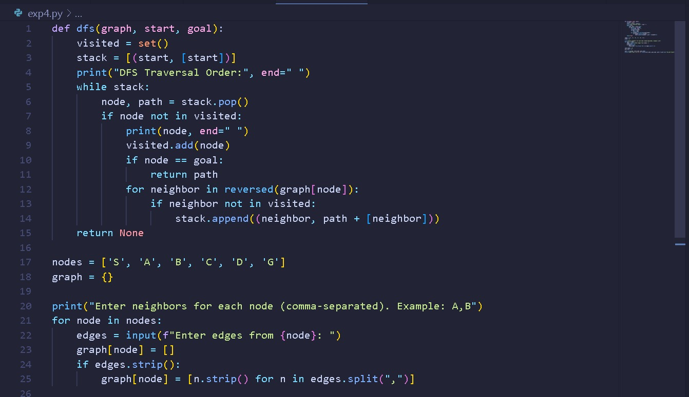
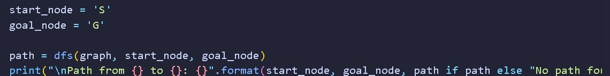

Output:
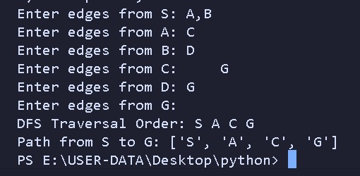

Conclusion: Therefore, this is the program to implement Depth First Search Algorithm (Uninformed) in Python.

EXPERIMENT-5
AIM: Write program to implement Greedy Best-First (Informed Type) Search
Algorithm in python.
Course Outcome: Implement relevant search algorithms as applicable to Artificial Intelligence.
Theory:
Greedy Best-First Search is an informed search algorithm used in Artificial Intelligence to find a path from a start node to a goal node in a state space or graph. Unlike uninformed search strategies such as Breadth-First Search (BFS) or Depth-First Search (DFS), GBFS uses domain-specific heuristic information to guide the search. The heuristic is a function h(n) that estimates the cost of the cheapest path from the current node n to the goal node. The algorithm always selects the node that appears to be closest to the goal according to this heuristic, hence the name greedy.
The search begins from the start node and maintains a priority queue (or min-heap) of frontier nodes, where the priority of each node is based solely on its heuristic value h(n). At every step, the node with the smallest h(n) is removed from the queue and expanded. Its unvisited neighbors are added to the frontier along with their heuristic estimates. This process continues until the goal node is reached or the frontier becomes empty (meaning no solution exists).
The main advantage of Greedy Best-First Search is that it is generally faster and uses less memory than algorithms that consider full path costs (like A*), because it only focuses on the estimated distance to the goal. However, this same property also makes GBFS incomplete and not optimal—it may get stuck in local minima or follow a path that seems promising but is actually longer than necessary. Despite these drawbacks, GBFS is useful in applications such as robot navigation, route finding, and game AI, where a quick solution is more important than the optimal one. Its time complexity depends on the quality of the heuristic function: a good heuristic can drastically reduce the number of explored nodes, while a poor heuristic can cause the algorithm to behave like an uninformed search.
In summary, Greedy Best-First Search provides a balance between efficiency and simplicity, making it an important stepping stone toward more advanced algorithms like A*, which combines both heuristic and path cost for optimal solutions.
Program:
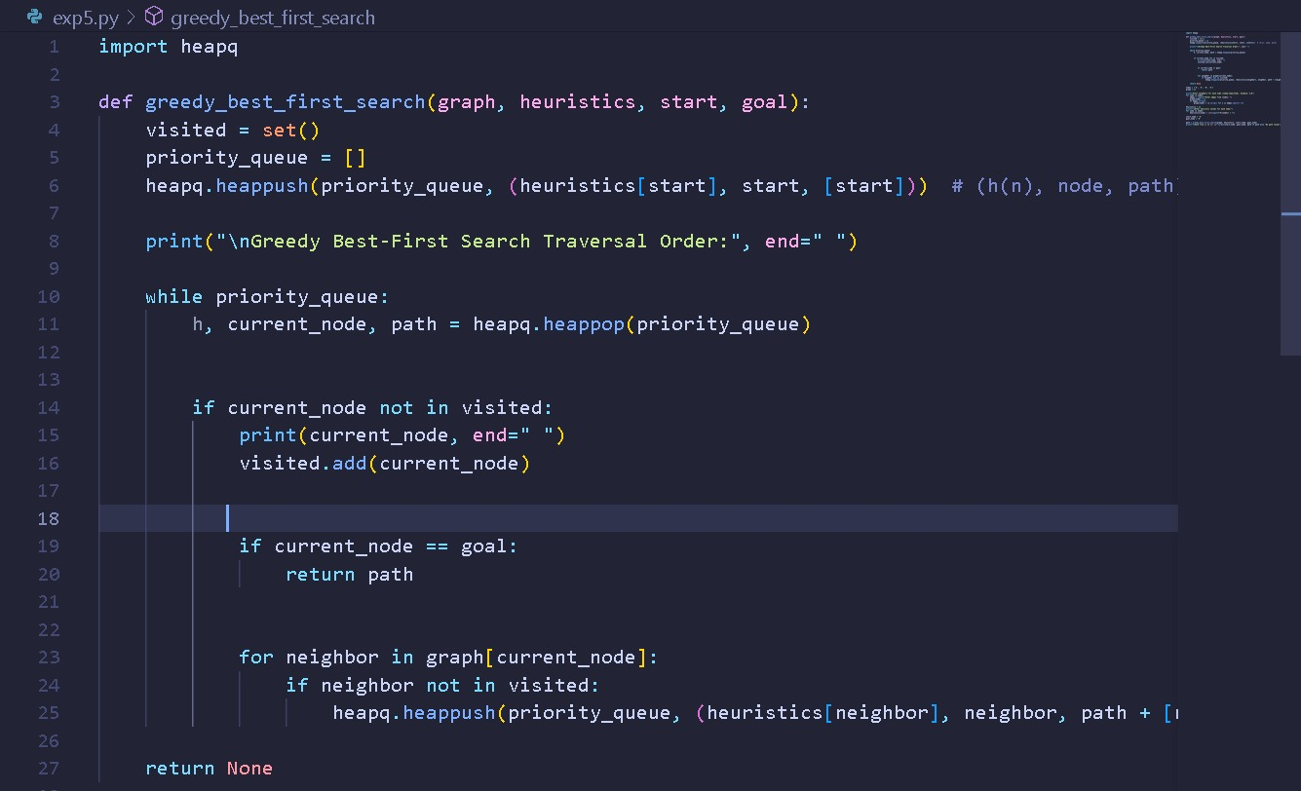
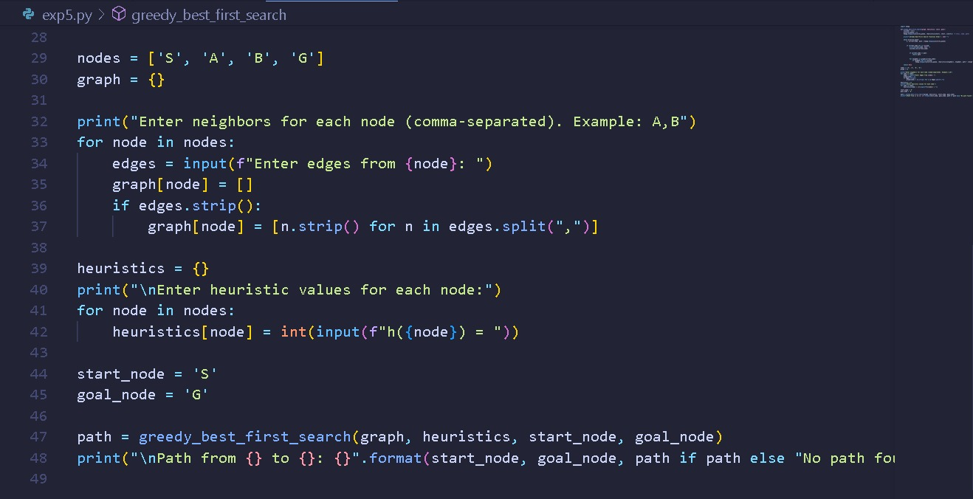

Output:
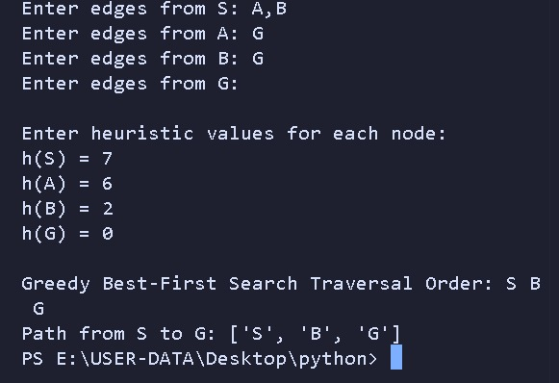

Conclusion: Hence, this is the program to implement Greedy Best-First Search Algorithm in python.

EXPERIMENT-6
AIM: Write program to implement A* search Algorithm in Python
Course Outcome: Implement relevant search algorithms as applicable to Artificial Intelligence.
Theory:
A* (A-Star) Search is one of the most powerful and widely used informed search algorithms in Artificial Intelligence. It is designed to efficiently find the shortest path between a start node and a goal node by combining the strengths of Uniform Cost Search (which guarantees optimality by considering path cost) and Greedy Best-First Search (which uses a heuristic to guide the search). A* evaluates nodes using a cost function:
f(n)=g(n)+h(n) where;
g(n) = actual cost from the start node to the current node n (path cost).
h(n) = heuristic estimate of the cost from n to the goal.
f(n) = total estimated cost of the cheapest solution through n.
During the search, A* maintains an open list (priority queue) of nodes to be explored, ordered by their f(n) values, and a closed list of nodes already explored. At every step, it selects the node with the lowest f(n) for expansion. If the heuristic function h(n) is admissible (never overestimates the true cost) and consistent (monotonic), A* is guaranteed to find the optimal solution. This makes it superior to purely greedy algorithms, which may reach the goal faster but can fail to find the shortest path.
The efficiency of A* depends heavily on the quality of the heuristic. A well-designed heuristic dramatically reduces the number of explored nodes, making the algorithm fast and memory efficient.
For example, in navigation problems, the straight-line distance to the goal is a common heuristic. Applications of A* include robot path planning, game development, network routing, and natural language processing. Its time and space complexity can be high in very large graphs because it keeps all generated nodes in memory, but with a good heuristic it remains one of the most practical algorithms for real-world search problems.
In summary, A* search finds the optimal path by intelligently balancing exploration of new nodes (using g(n)) and exploitation of heuristic guidance (using h(n)), making it both complete and optimal as long as the heuristic meets the admissibility condition.

Program:
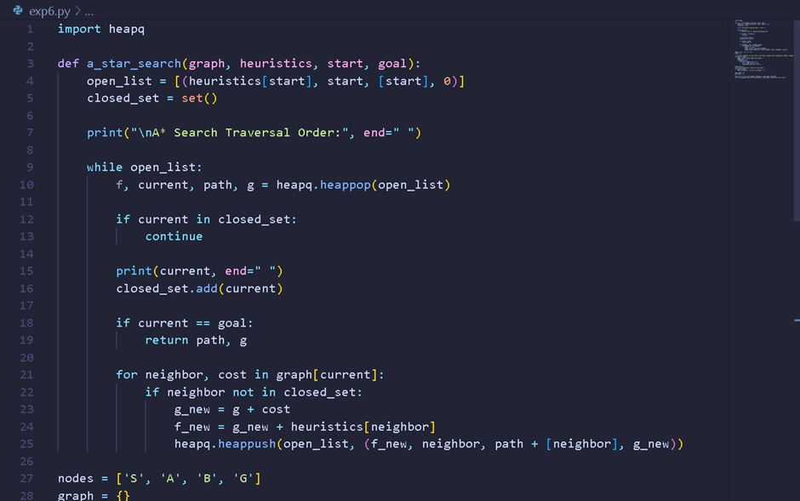
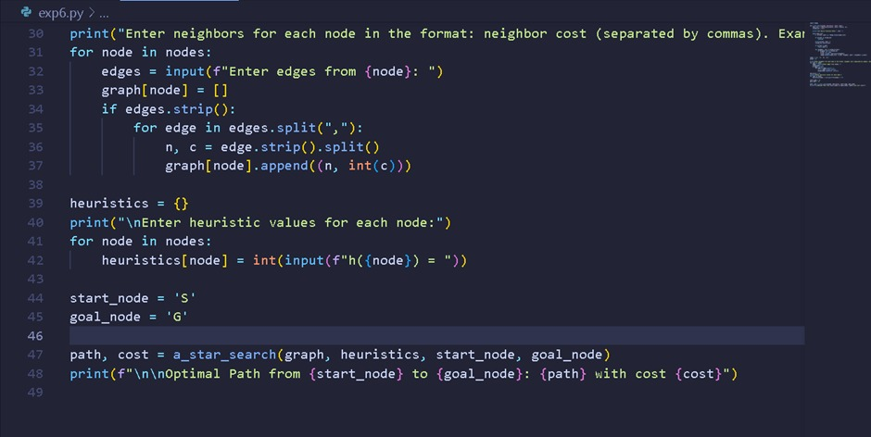

Output:
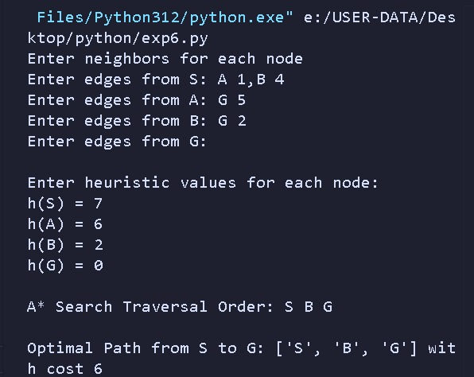

Conclusion: Hence, this is the program to implement A* search (Informed Type) Algorithm in Python.

EXPERIMENT 10

Aim: Write a program in python to split any data set into train and tests sets
Course Outcome: Analyze different forms of data with respect to different phases of Machine Learning.
Theory:
Splitting a dataset is a fundamental and crucial step in the machine learning workflow. The core idea is to partition your data into at least two independent sets: a training set and a testing set.
- Training Set : This is the majority of your data (commonly 70-80%). The machine learning model "studies" this data to learn the underlying patterns, relationships, and rules. The model is built or "fit" using only this data.
- Testing Set : This is the remaining portion of your data (commonly 20-30%). This data is kept completely separate and is never shown to the model during the training phase. After the model is trained, we use the testing set to evaluate its performance and see how well it performs on new, unseen data.
The primary reason for splitting data is to prevent overfitting and build a model that generalizes well.
- Overfitting: This occurs when a model learns the training data too well. It memorizes not only the underlying patterns but also the noise and random fluctuations in the training data. An overfitted model will be incredibly accurate on the data it was trained on but will perform poorly when it encounters new, unseen data because it hasn't learned the general rules.
  - Analogy: Imagine a student preparing for a math exam. An overfitted student would memorize the exact answers to every question in the practice booklet (the training set). They would score 100% on that practice test. However, when given the final exam (the testing set), which has slightly different questions, they would fail because they never learned the underlying mathematical concepts (the general pattern).
- Generalization: The ultimate goal of a machine learning model is to generalize—to accurately predict outcomes for data it has never seen before. By evaluating the model on a separate test set, we get a realistic estimate of how it will perform in the real world.
If a model has high accuracy on the training set but low accuracy on the testing set, it is a clear sign of overfitting.

Program :

Feeding data into the code
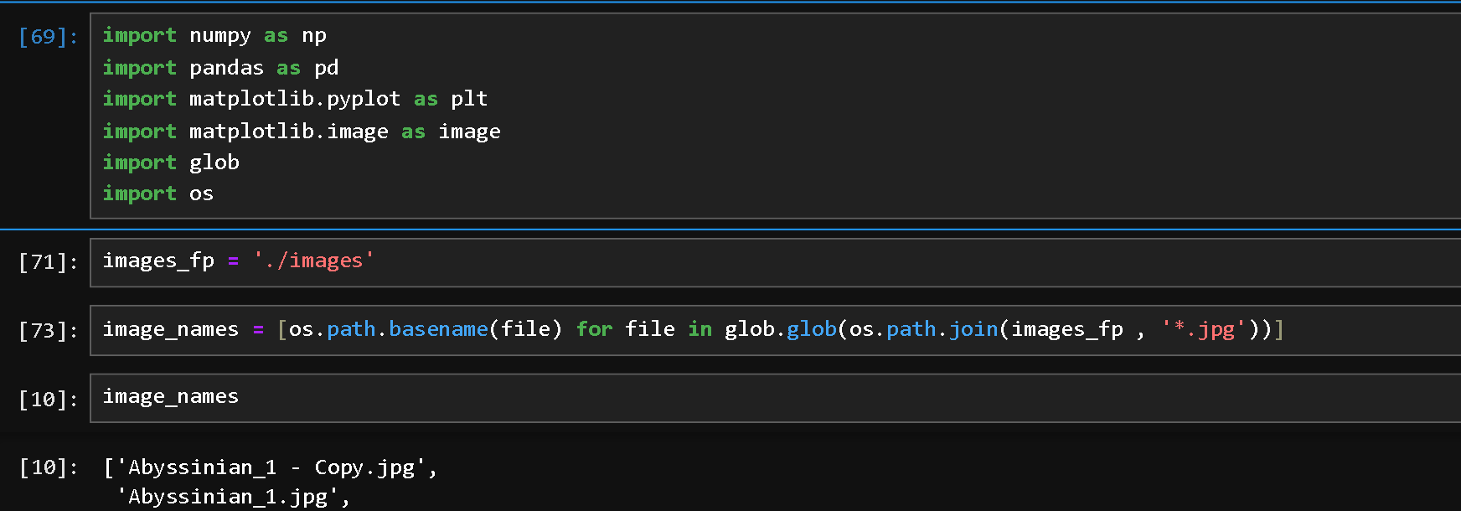

Dividing data into train test split using sklearn library
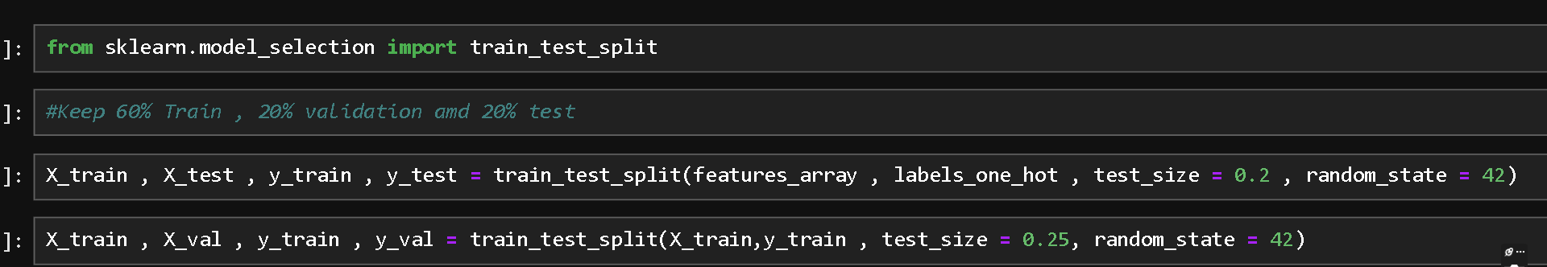

Output
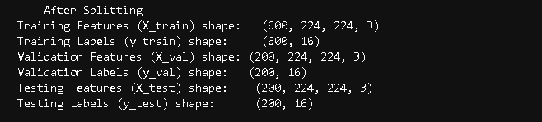
Conclusion :
Splitting a dataset into training and testing sets is a fundamental step in building a machine learning model. This division allows the model to learn patterns from the training data and then be evaluated on unseen testing data. This process is crucial for assessing the model's real-world performance and ensuring it can generalize effectively to new information.

EXPERIMENT 9

AIM: Build model on following data sets in various domains.
a.
Machine Learning data set: e.g. Credit Card Fraud Detection Dataset
b.
NLP data sets: eg. Twitter Dataset, HotspotQA Dataset
Course Outcome: Analyze different forms of data with respect to different phases of Machine Learning.
Theory:
  - Credit Card Fraud Detection Dataset
The Python script you have is a practical application of several fundamental machine learning concepts, especially those relevant to dealing with imbalanced classification problems. Here’s a breakdown of the theory behind each step.
1. The Problem: Imbalanced Classification
Credit card fraud detection is a classic example of an imbalanced classification problem. This means that one class of the target variable is vastly more common than the other.
- Majority Class: Legitimate transactions (labeled as 0).
- Minority Class: Fraudulent transactions (labeled as 1).
In your dataset, non-fraudulent transactions make up over 99.8% of the data. This imbalance is the central challenge because a naive model could achieve 99.8% accuracy by simply predicting "not fraud" for every transaction, while being completely useless at its actual goal of catching fraud. Therefore, standard accuracy is a poor metric for this problem.
2. Data Preprocessing: Feature Scaling
The StandardScaler is used to standardize the Time and Amount features.
- Why is Scaling Necessary? Many machine learning algorithms, including the Logistic Regression used here, perform better when numerical input features are on a similar scale. If one feature (like Amount) has a much larger range of values than others, it can dominate the learning process and cause the model to be biased.
- How StandardScaler Works: It transforms each feature by subtracting its mean and dividing by its standard deviation. This results in a new distribution for the feature with a mean of 0 and a standard deviation of 1. This ensures that all features have a comparable influence on the model.
- PCA Components (V1-V28): It's worth noting that the other features in this dataset are the result of a Principal Component Analysis (PCA) transformation. This was done to anonymize sensitive user data while retaining most of the important statistical information. These PCA components are already scaled, which is why we only need to scale Time and Amount.
3. Splitting the Data: Stratification
When splitting the data, the parameter stratify=y is crucial.
- Random vs. Stratified Splitting: A simple random split could, by chance, result in the training set having a different percentage of fraud cases than the test set. In an extreme case with a very small dataset, the test set might end up with no fraud cases at all, making it impossible to evaluate the model's ability to detect fraud.
- Stratified Splitting: This method ensures that both the training and testing sets have the same proportion of each class as the original dataset. For fraud detection, this guarantees that both sets contain approximately 0.172% fraudulent transactions, leading to a much more reliable and realistic evaluation.
4. Model Choice: Logistic Regression as a Baseline
Logistic Regression is a simple yet powerful linear model for binary classification.
- How it Works: It calculates the probability that a given input belongs to a specific class (in this case, "Fraud" or 1). It does this by passing the weighted sum of the inputs through a sigmoid function, which squashes the output value to a probability between 0 and 1. If the probability crosses a certain threshold (typically 0.5), the model assigns the input to that class.
- Why a Baseline? It is used as a baseline model because it is fast to train and easy to interpret. Its performance provides a benchmark against which more complex models (like Random Forests or Gradient Boosting) can be compared to see if their added complexity provides a meaningful improvement.
5. Evaluating Performance on Imbalanced Data
Because accuracy is misleading, we use a more nuanced set of metrics derived from the Confusion Matrix.
The Confusion Matrix
The confusion matrix gives a clear picture of where the model is getting things right and where it's making mistakes.
- True Positives (TP): The model correctly predicted Fraud when it was actually Fraud. (This is what we want).
- True Negatives (TN): The model correctly predicted Non-Fraud when it was actually Non-Fraud.
- False Positives (FP) - Type I Error: The model incorrectly predicted Fraud when it was actually Non-Fraud. (A legitimate transaction is blocked).
- False Negatives (FN) - Type II Error: The model incorrectly predicted Non-Fraud when it was actually Fraud. (A fraudulent transaction is missed).
For fraud detection, minimizing False Negatives is the top priority, as they represent direct financial loss.
Key Metrics from the Matrix
The classification report uses the values from the confusion matrix to calculate more informative scores:
- Precision: Error! Filename not specified.
  - Question it answers: "Out of all the transactions we flagged as fraudulent, what percentage were actually fraudulent?"
  - High precision is important to avoid inconveniencing legitimate customers with false alarms (False Positives).
- Recall (Sensitivity or True Positive Rate): Error! Filename not specified.
  - Question it answers: "Out of all the actual fraudulent transactions that occurred, what percentage did we successfully catch?"
  - This is often the most important metric in fraud detection. High recall means the model is effective at minimizing financial losses (lowering False Negatives).
- F1-Score: Error! Filename not specified.
  - The F1-score is the harmonic mean of Precision and Recall. It provides a single number that balances the two metrics, which is useful when you need to compare different models. A high F1-score indicates that the model has both low false positives and low false negatives.

Program :
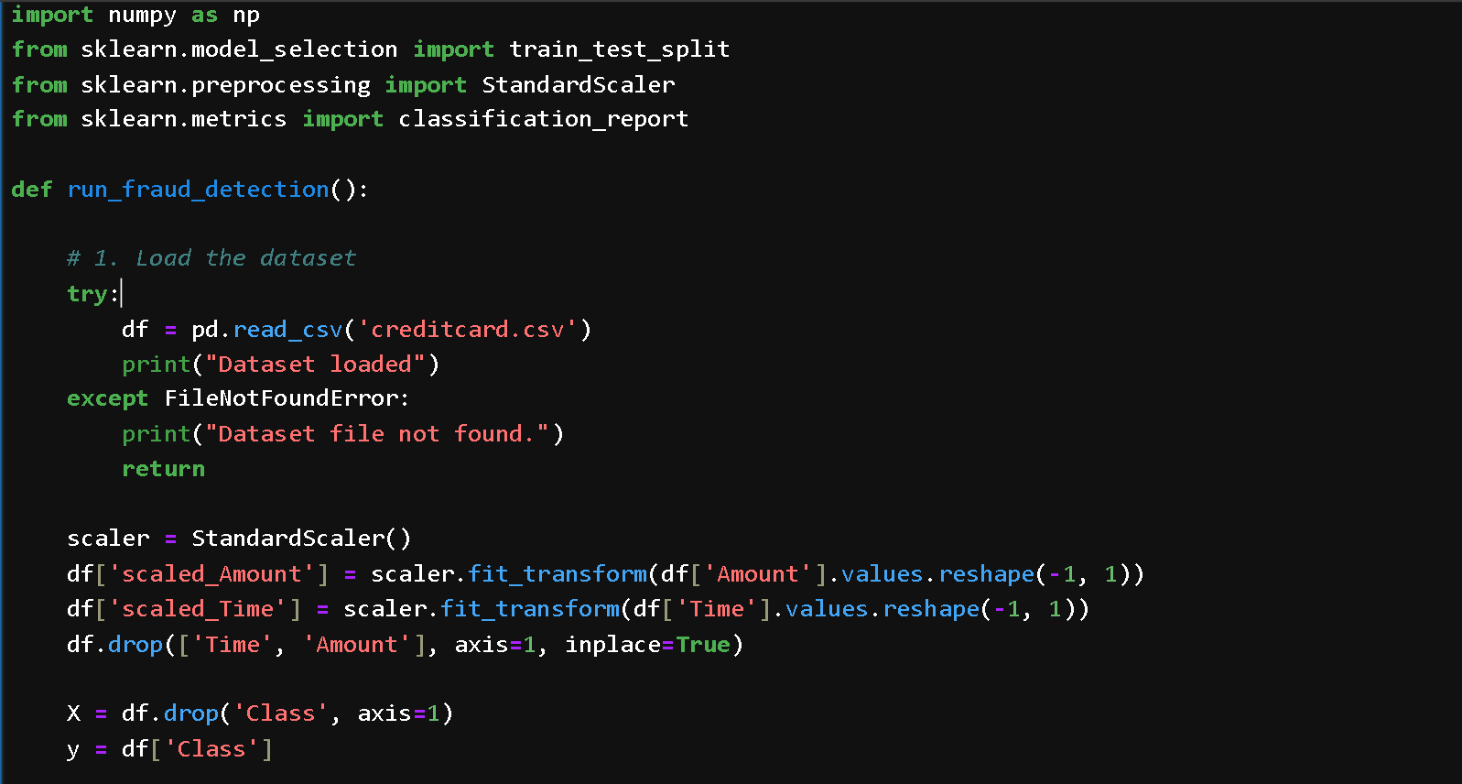
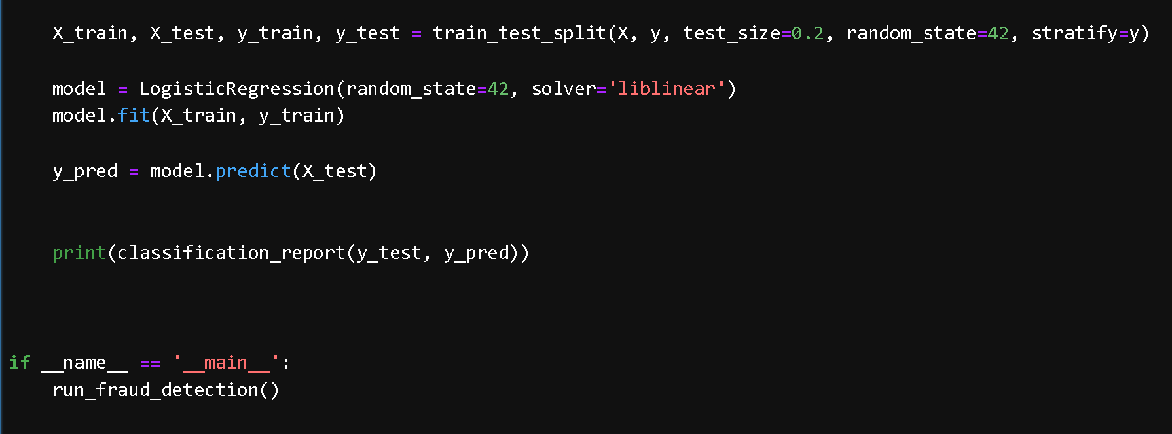

Output :
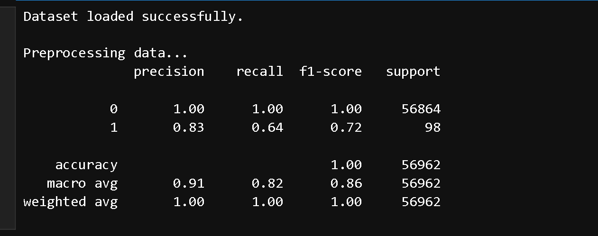

  - NLP data sets: (IMdb Reviews)

Program :
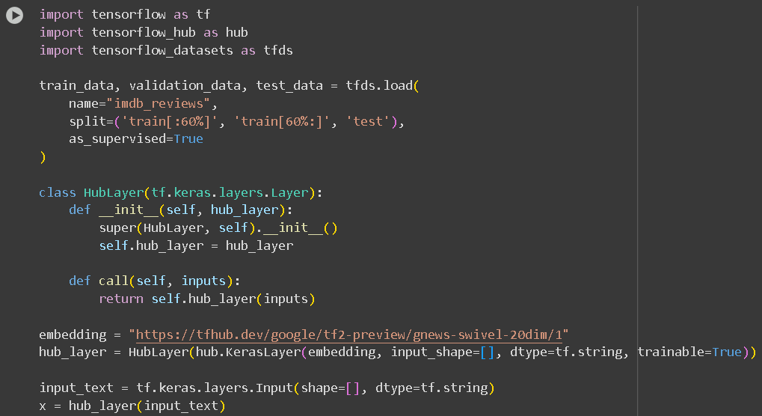

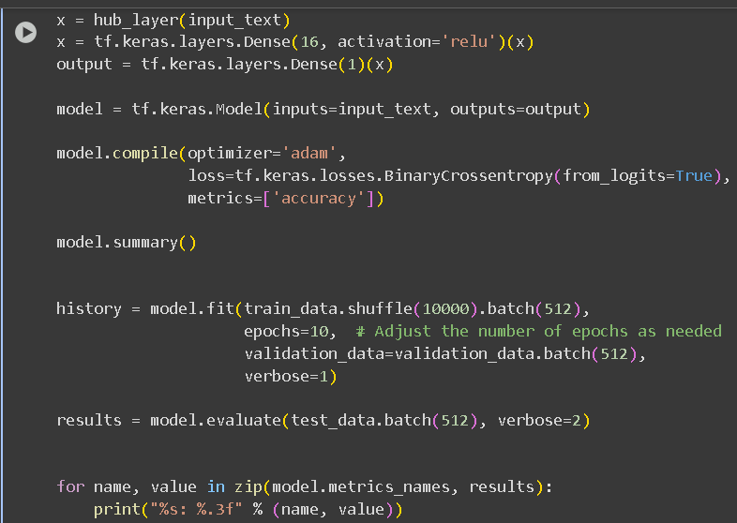

Output :

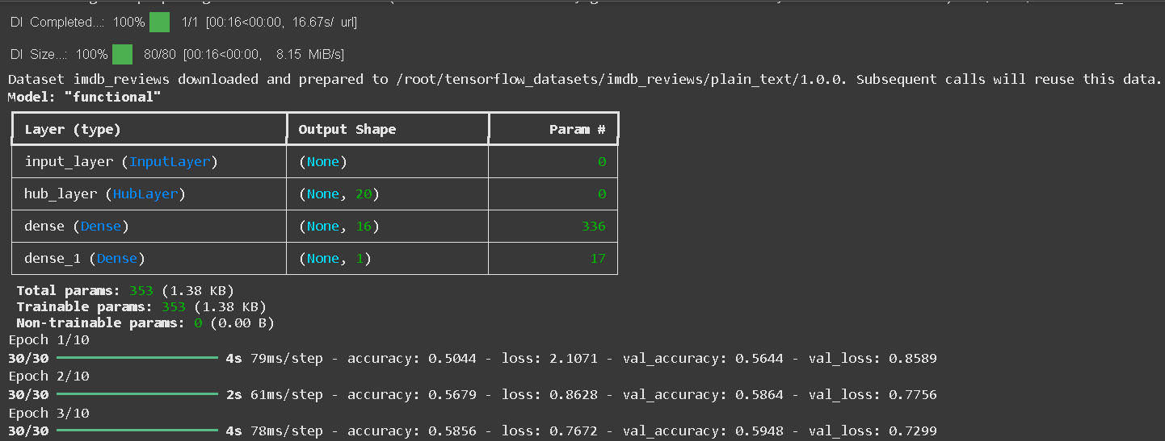
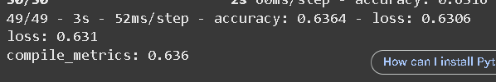

Conclusion:
Tackling datasets from different domains like machine learning and NLP is a great way to build versatile skills.

